Task 1

INCLUDE Irvine32.inc

.data

num DWORD 21

op DWORD 0

.code

main PROC

mov eax, 10

mov ebx,num

mov ecx, 0

l1:

test ebx, ebx

jz l2

shl eax,1

rcl op,1

shr ebx,1

inc ecx

cmp ecx,5

jl l1

l2:

call dumpregs

exit

main ENDP

END main

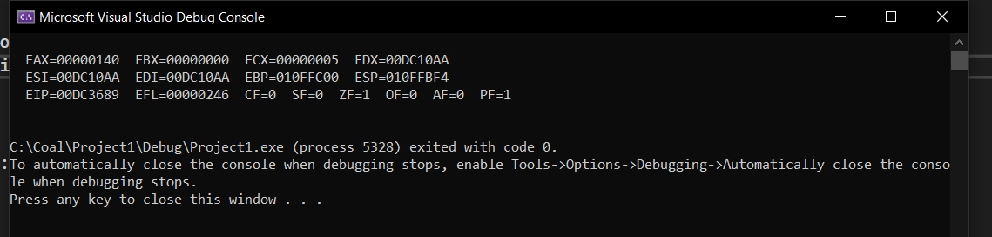

Task 2

INCLUDE Irvine32.inc

.data

num SWORD -128

.code

main PROC

mov ax,num

mov cl,16

sar ax,1

rcr ax,cl

movsx eax,ax

call writeint

exit

main ENDP

END main

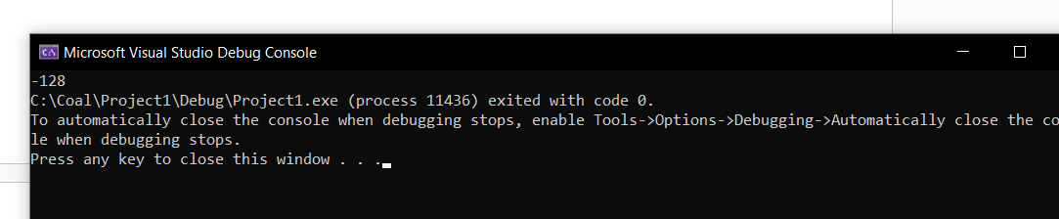

Task 3

INCLUDE Irvine32.inc

.data

time WORD 0010011000001111b

.code

main PROC

mov ax, time

call ShowFileTime

exit

main ENDP

ShowFileTime PROC

push ebx

push edx

and eax,0FFFFh

mov bx,ax

shr ax,11

cmp ax,10

jae L1

call DisplayZero

L1: call WriteDec

mov al,':'

call WriteChar

mov ax,bx

shr ax,5

and ax,0000000000111111b

cmp ax,10

jae L2

call DisplayZero

L2: call WriteDec

mov al, ':'

call WriteChar

mov ax,bx

and ax,0000000000001111b

cmp ax,10

jae L3

call DisplayZero

L3: call WriteDec

call Crlf

pop edx

pop ebx

ret

ShowFileTime ENDP

DisplayZero PROC

push eax

mov al,'0'

call WriteChar

pop eax

ret

DisplayZero ENDP

END main

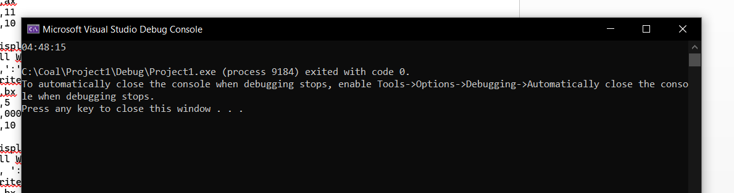

Task 4

INCLUDE Irvine32.inc

.data

s WORD 2315h

s1 WORD 8573h

.code

main PROC

mov ax, s

mov bx, s1

shl ax, 88

shr bx, 7

or bx, ax

call dumpregs

exit

main ENDP

END main

;without SHRD

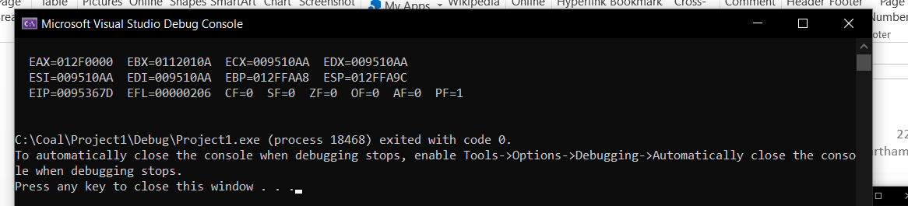

INCLUDE Irvine32.inc

.data

s WORD 7575h

s1 WORD 2341h

.code

main PROC

mov ax, s

mov bx, s1

shrd bx, ax, 1

call dumpregs

exit

main ENDP

END main

;with SHRD

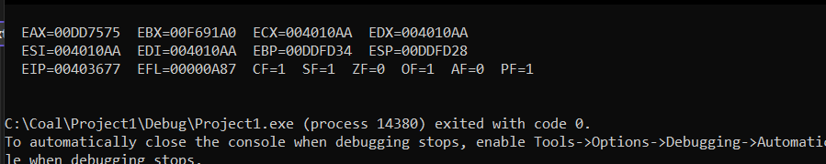

Task 5

INCLUDE Irvine32.inc

.data

var1 DWORD 10

var2 DWORD 4

var3 DWORD 2

.code

main PROC

mov eax, var1

cdq

mov ebx, var3

idiv ebx

mov ecx,eax

mov eax, var1

cdq

mov ebx, var3

idiv ebx

mov eax,ecx

imul eax,ebx

mov var1,eax

call writeint

exit

main ENDP

END main

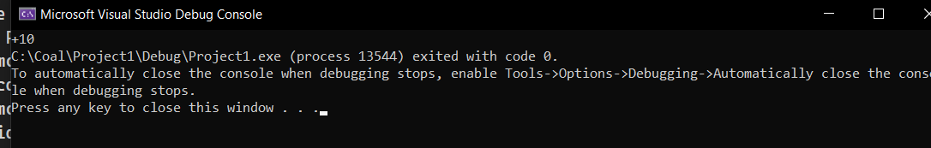

Task 6

INCLUDE Irvine32.inc

.data

int1 dword 12

int2 dword 98

result dword 0

.code

Extended_Add PROC

mov eax,int1

add eax,int2

call writeint

mov result,eax

ret

Extended_Add ENDP

main PROC

call Extended_Add

exit

main ENDP

END main

